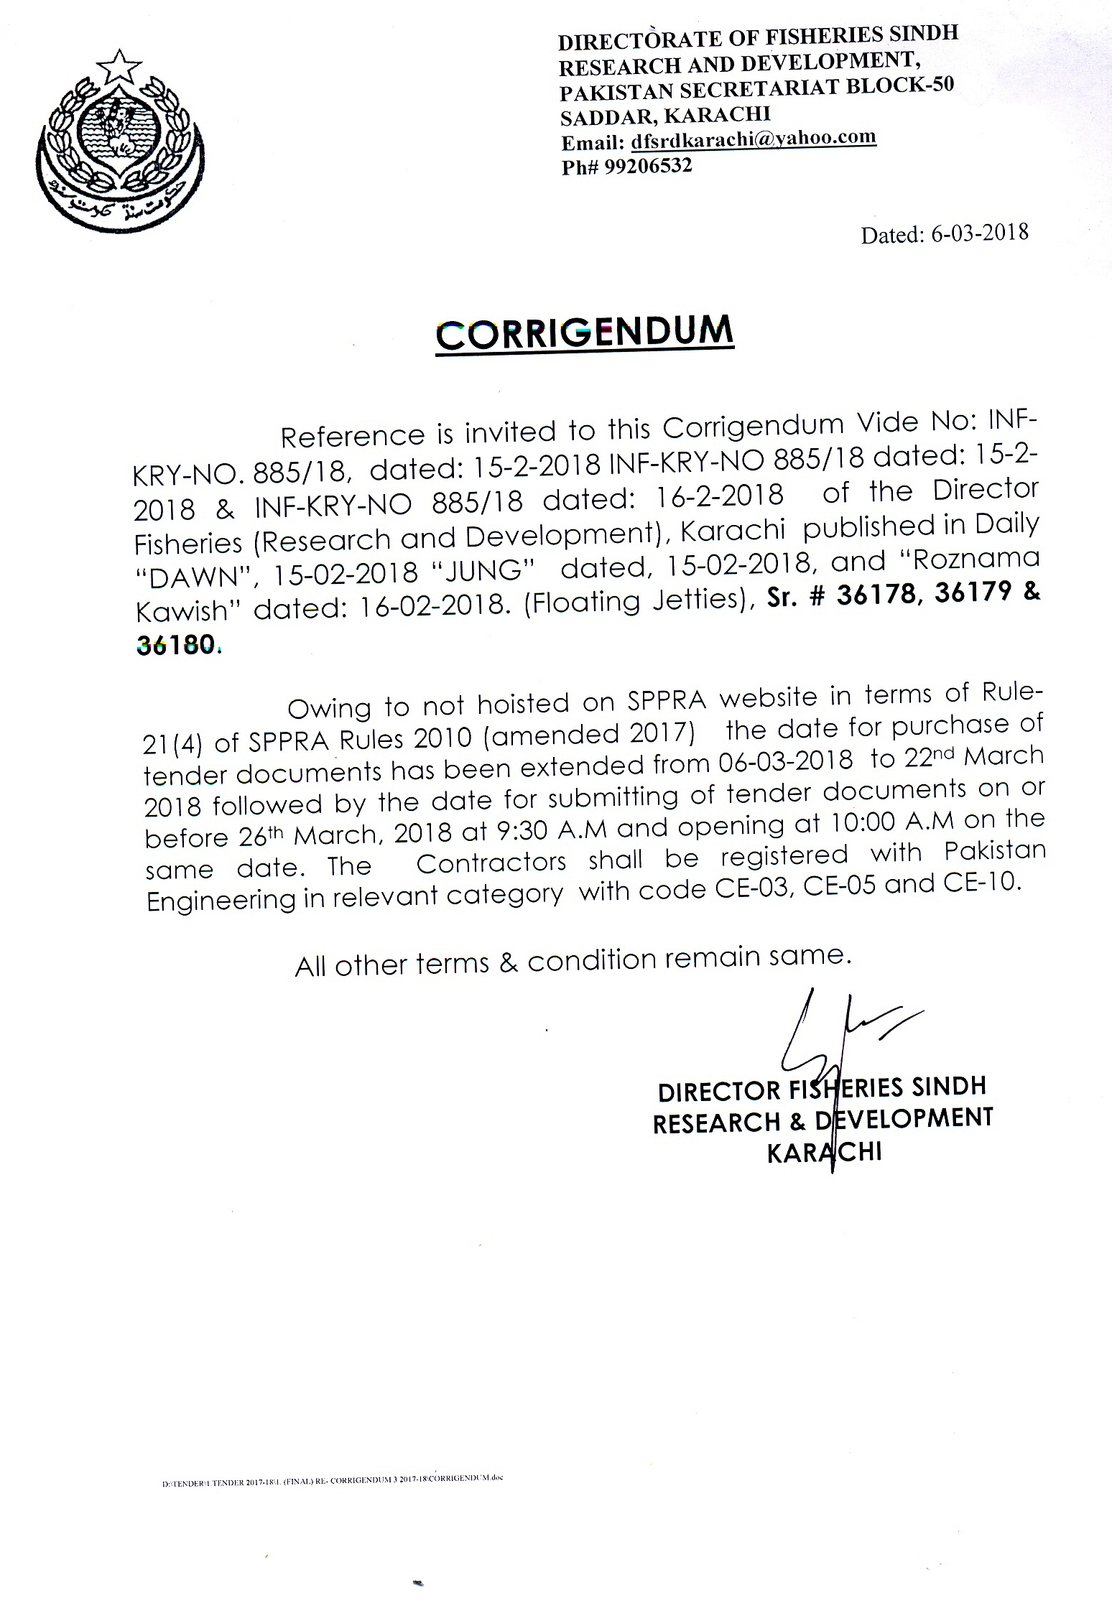

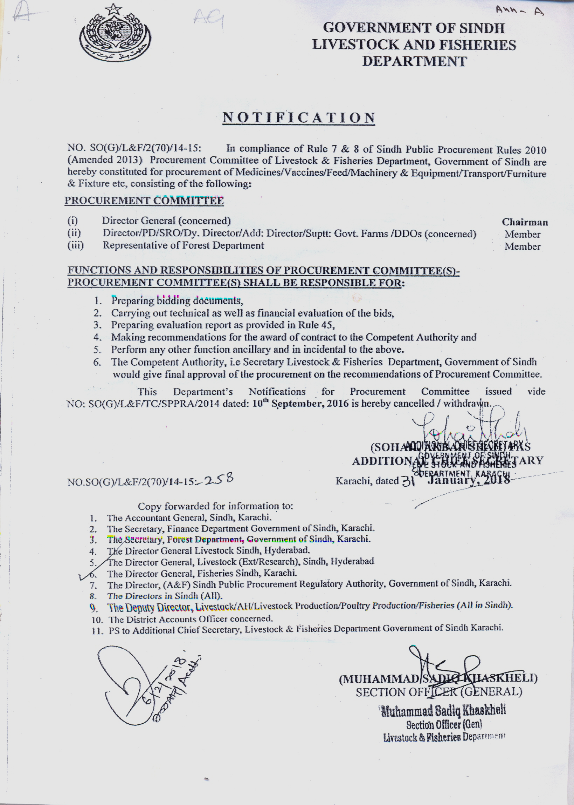



SECTION – II

INSTRUCTIONS TO BIDDERS
INSTRUCTIONS TO BIDDERS
(Note: These Instructions to Bidders along with Bidding Data will not be part of the Contract and will cease to have effect once the contract is signed.)
A. GENERAL
IB.1 Scope of Bid
1.1 The Procuring Agency as defined in the Bidding Data hereinafter called “the Procuring Agency” wishes to receive bids for the works summarized in the Bidding Data (hereinafter referred to as the “Works”).
1.2 The successful bidder will be expected to complete the Works within the time specified in Appendix-A to Bid.
IB.2 Source of Funds
2.1 The Procuring Agency has arranged funds from Sindh Government indicated in the Bidding Data towards the cost of the project “FLOATING JETTY FOR TRANSPORTATION AT SHAMS PIR ISLAND, UC-41 BABA BHIT, KEAMARI TOWN, KARACHI WEST”.
IB.3 Eligible Bidders
3.1 This Invitation for Bids is open to all bidders meeting the following requirements:
a. Duly licensed by the Pakistan Engineering Council (PEC) in the relevant category with Codes CE-03, CE-05 & CE-10.
IB.4 One Bid per Bidder
4.1 Each bidder shall submit only one bid either by himself, or as a partner in a joint venture. A bidder who submits or participates in more than one bid (other than alternatives pursuant to Clause IB.16) will be disqualified.
IB.5 Cost of Bidding
5.1 The bidders shall bear all costs associated with the preparation and submission of their respective bids and the Procuring Agency will in no case be responsible or liable for those costs, regardless of the conduct or outcome of the bidding process.
IB.6 Site Visit
6.1 The bidders are advised to visit and examine the Site of Works and its surroundings and obtain for themselves on their own responsibility all information that may be necessary for preparing the bid and entering into a contract for construction of the Works. All cost in this respect shall be at the bidder’s own expense.
6.2 The bidders and any of their personnel or agents will be granted permission by the Procuring Agency to enter upon his premises and lands for the purpose of such inspection, but only upon the express condition that the bidders, their personnel and agents, will release and indemnify the Procuring Agency, his personnel and agents from and against all liability in respect thereof and will be responsible for death or personal injury, loss of or damage to property and any other loss, damage, costs and expenses incurred as a result of such inspection.

B. BIDDING DOCUMENTS
IB.7 Contents of Bidding Documents
7.1 The Bidding Documents, in addition to invitation for bids, are those stated below and should be read in conjunction with any Agenda issued in accordance with Clause IB.9.
1. Instructions to Bidders.
2. Bidding Data.
3. General Conditions of Contract, Part-I (GCC).
4. Particular Conditions of Contract, Part-II (PCC).
5. Specifications – Special Provisions.
6. Specifications - Technical Provisions.
7. Form of Bid & Appendices to Bid.
8. Bill of Quantities (Appendix-D to Bid).
9. Form of Bid Security.
10. Form of Contract Agreement.
11. Forms of Performance Security and Mobilization Advance Guarantee/Bond.
12. Drawings.
7.2 The bidders are expected to examine carefully the contents of all the above documents. Failure to comply with the requirements of bid submission will be at the Bidder’s own risk. Pursuant to Clause IB.26, bids which are not substantially responsive to the requirements of the Bidding Documents will be rejected.
IB.8 Clarification of Bidding Documents
8.1 Any prospective bidder requiring any clarification (s) in respect of the Bidding Documents may notify the Procuring Agency in writing at the Procuring Agency address indicated in the Invitation for Bids. The Procuring Agency will respond to any request for clarification which he receives earlier than 28 days prior to the deadline for submission of bids.
Copies of the Procuring Agency response will be forwarded to all purchasers of the Bidding Documents, including a description of the enquiry but without identifying its source.
IB.9 Amendment of Bidding Documents
9.1 At any time prior to the deadline for submission of bids, the Procuring Agency may, for any reason, whether at his own initiative or in response to a clarification requested by a prospective bidder, modify the Bidding Documents by issuing addendum.
9.2 Any addendum thus issued shall be part of the Bidding Documents pursuant to Sub- Clause 7.1 hereof and shall be communicated in writing to all purchasers of the Bidding Documents. Prospective bidders shall acknowledge receipt of each addendum in writing to the Procuring Agency.
9.3 To afford prospective bidders reasonable time in which to take an addendum into account in preparing their bids, the Procuring Agency may extend the deadline for submission of bids in accordance with Clause IB.20
C. PREPARATION OF BIDS
IB.10 Language of Bid
10.1 The bid and all correspondence and documents related to the bid exchanged by a bidder and the Procuring Agency shall be in the bid language stipulated in the Bidding Data and Particular Conditions of Contract. Supporting documents and printed literature furnished by the bidders may be in any other language provided the same are accompanied by an accurate translation of the relevant parts in the bid language, in which case, for purposes of evaluation of the bid, the translation in bid language shall prevail.
IB.11 Documents Accompanying the Bid
11.1 Each bidder shall:
(a) submit a written power of attorney authorizing the signatory of the bid to act for and on behalf of the bidder;

(b) update the information indicated and listed in the Bidding Data and previously submitted with the application for prequalification, and continue to meet the minimum criteria set out in the prequalification documents which as a minimum, would include the following :

(i) Evidence of access to financial resources along with average annual construction turnover;
(ii) Financial predictions for the current year and the two following years including the effect of known commitments;
(iii) Work commitments since prequalification;
(iv) Current litigation information; and
- Availability of critical equipment.

and

- furnish a technical proposal taking into account the various Appendices to Bid specially the following:
Appendix-E to Bid Proposed Construction Schedule
Appendix-F to Bid Method of Performing the Work
Appendix-G to Bid List of Major Equipment
Appendix-K to Bid Organization Chart for Supervisory Staff
and other pertinent information such as mobilization programme etc;

11.2 Bids submitted by a joint venture of two (2) or more firms shall comply with the following requirements:

(a) the bid and in case of a successful bid, the Form of Contract Agreement shall be signed so as to be legally binding on all partners;
(b) one of the joint venture partners shall be nominated as being in charge; and this authorization shall be evidenced by submitting a power of attorney signed by legally authorized signatories of all the joint venture partners;
(c) the partner-in-charge shall always be duly authorized to deal with the Procuring Agency regarding all matters related with and/or incidental to the execution of Works as per the terms and Conditions of Contract and in this regard to incur any and all liabilities, receive instructions, give binding undertakings and receive payments on behalf of the joint venture;
(d) all partners of the joint venture shall at all times and under all circumstances be liable jointly and severally for the execution of the Contract in accordance with the Contract terms and a statement to this effect shall be included in the authorization mentioned under Sub-Para(b) above as well as in the Form of Bid and in the Form of Contract Agreement (in case of a successful bid); and
(e) a copy of the agreement entered into by the joint venture partners shall be submitted with the bid stating the conditions under which it will function, its period of duration, the persons authorized to represent and obligate it and which persons will be directly responsible for due performance of the Contract and can give valid receipts on behalf of the joint venture, the proportionate participation of the several firms forming the joint venture, and any other information necessary to permit a full appraisal of its functioning. No amendments / modifications whatsoever in the joint venture agreement shall be agreed to between the joint venture partner without prior written consent of the Procuring Agency.
11.3 Bidders shall also submit proposals of work methods and schedule, in sufficient detail to demonstrate the adequacy of the Bidders’ proposals to meet the technical specifications and the completion time referred to in Sub-Clause 1.2 hereof.
IB.12 Bid Prices
12.1 Unless stated otherwise in the Bidding Documents, the Contract shall be for the whole of the Works as described in Sub-Clause 1.1 hereof, based on the unit rates and / or prices submitted by the bidder.

12.2 The bidders shall fill in rates and prices for all items of the Works described in the Bill of Quantities. Items against which no rate or price is entered by a bidder will not be paid for by the Procuring Agency when executed and shall be deemed covered by rates and prices for other items in the Bill of Quantities.
12.3 All duties, taxes and other levies payable by the Contractor under the Contract, or for any other cause, as on the date 28 days prior to the deadline for submission of bids shall be included in the rates and prices and the total Bid Price submitted by a bidder.
Additional / reduced duties, taxes and levies due to subsequent additions or changes in legislation shall be reimbursed / deducted as per Sub-Clause 70.2 of the General Conditions of Contract Part-I.
12.4 The rates and prices quoted by the bidders are subject to adjustment during the performance of the Contract in accordance with the provisions of Clause 70 of the Conditions of Contract. The bidders shall furnish the prescribed information for the price adjustment formulae in Appendix-C to Bid, and shall submit with their bids such other supporting information as required under the said Clause.

IB.13 Currencies of Bid and Payment
13.1 The unit rates and the prices shall be quoted by the bidder entirely in Pak rupees. A bidder expecting to incur expenditures in other currencies for inputs to the Works supplied from outside the Procuring Agency ’s country (referred to as the “Foreign Currency Requirements”) shall indicate the same in Appendix-B to Bid. The proportion of the Bid Price (excluding Provisional Sums) needed by him for the payment of such Foreign Currency Requirements either (i) entirely in the currency of the Bidder’s home country or, (ii) at the bidder’s option, entirely in Pak rupees provided always that a bidder expecting to incur expenditures in a currency or currencies other than those stated in (i) and (ii) above for a portion of the foreign currency requirements, and wishing to be paid accordingly, shall indicate the respective portions in his bid.
13.2 The rates of exchange to be used by the bidder for currency conversion shall be the TT&OD Selling Rates published or authorized by the State Bank of Pakistan prevailing on the date 28 days prior to the deadline for submission of bids.
For the purpose of payments, the exchange rates used in bid preparation shall apply for the duration of the Contract.
IB.14 Bid Validity
14.1 Bids shall remain valid for the period stipulated in the Bidding Data after the Date of Bid Opening specified in Clause IB.23.
14.2 In exceptional circumstances, prior to expiry of the original bid validity period, the Procuring Agency may request that the bidders extend the period of validity for a specified additional period which shall in no case be more than the original bid validity period. The request and the responses thereto shall be made in writing. A bidder may refuse the request without forfeiting his Bid Security. A bidder agreeing to the request will not be required or permitted to modify his bid, but will be required to extend the validity of his Bid Security for the period of the extension, and in compliance with Clause IB.15 in all respects.
IB.15 Bid Security
15.1 Each bidder shall furnish, as part of his bid, a Bid Security in the amount stipulated in the Bidding Data in Pak Rupees or an equivalent amount in a freely convertible currency.
15.2 The Bid Security shall be, at the option of the bidder, in the form of Deposit at Call or a Bank Guarantee issued by a Scheduled Bank in Pakistan or from a foreign bank duly counter guaranteed by a Scheduled Bank in Pakistan in favor of the Procuring Agency valid for a period 28 days beyond the Bid Validity date.
15.3 Any bid not accompanied by an acceptable Bid Security shall be rejected by the Procuring Agency as non-responsive.
15.4 The bid securities of unsuccessful bidders will be returned as promptly as possible, but not later than 28 days after the expiration of the period of Bid Validity.
15.5 The Bid Security of the successful bidder will be returned when the bidder has furnished the required Performance Security and signed the Contract Agreement.
15.6 The Bid Security may be forfeited:
(a) if the bidder withdraws his bid except as provided in Sub-Clause 22.1;
(b) if the bidder does not accept the correction of his Bid Price pursuant to Sub-Clause 27.2 hereof; or
(c) In the case of successful bidder, if he fails within the specified time limit to:
(i) furnish the required Performance Security; or
(ii) sign the Contract Agreement.
IB.16 Alternate Proposals by Bidder
16.1 Should any bidder consider that he can offer any advantages to the Procuring Agency by a modification to the designs, specifications or other conditions, he may, in addition to his bid to be submitted in strict compliance with the Bidding Documents, submit any Alternate Proposal(s) containing (a) relevant design calculations; (b) technical specifications; (c) proposed construction methodology; and (d) any other relevant details / conditions, provided always that the total sum entered on the Form of Bid shall be that which represents complete compliance with the Bidding Documents.

16.2 Alternate Proposal(s), if any, of the lowest evaluated responsive bidder only may be considered by the Procuring Agency as the basis for the award of Contract to such bidder.
IB.17 Pre-Bid Meeting
17.1 The Procuring Agency may, on his own motion or at the request of any prospective bidder(s), hold a pre-bid meeting to clarify issues and to answer any questions on matters related to the Bidding Documents. The date, time and venue of pre-bid meeting, if convened, is as stipulated in the Bidding Data. All prospective bidders or their authorized representatives shall be invited to attend such a pre-bid meeting.
17.2 The bidders are requested to submit questions, if any, in writing so as to reach the Procuring Agency not later than seven (7) days before the proposed pre-bid meeting.
17.3 Minutes of the pre-bid meeting, including the text of the questions raised and the replies given, will be transmitted without delay to all purchasers of the Bidding Documents. Any modification of the Bidding Documents listed in Sub-Clause 7.1 hereof which may become necessary as a result of the pre-bid meeting shall be made by the Procuring Agency exclusively through the issue of an Addendum pursuant to Clause IB.9 and not through the minutes of the pre-bid meeting.
17.4 Absence at the pre-bid meeting will not be a cause for disqualification of a bidder.
IB.18 Format and Signing of Bid
  - Bidders are particularly directed that the amount entered on the Form of Bid shall be for performing the Contract strictly in accordance with the Bidding Documents.
18.2 All appendices to Bid are to be properly completed and signed.
18.3 No alteration is to be made in the Form of Bid nor in the Appendices thereto except in filling up the blanks as directed. If any such alterations be made or if these instructions be not fully complied with, the bid may be rejected.
18.4 Each bidder shall prepare by filling out the forms completely and without alterations one (1) original and number of copies, specified in the Bidding Data, of the documents comprising the bid as described in Clause IB.7 and clearly mark them “ORIGINAL” and ‘COPY” as appropriate. In the event of discrepancy between them, the original shall prevail.
18.5 The original and all copies of the bid shall be typed or written in indelible ink (in the case of copies, Photostats are also acceptable) and shall be signed by a person or persons duly authorized to sign on behalf of the bidder pursuant to Sub- Clause 11.1(a) hereof. All pages of the bid shall be initialed and stamped by the person or persons signing the bid.
18.6 The bid shall contain no alterations, omissions or additions, except to comply with instructions issued by the Procuring Agency, or as are necessary to correct errors made by the bidder, in which case such corrections shall be initialed by the person or persons signing the bid.
18.7 Bidders shall indicate in the space provided in the Form of Bid their full and proper addresses at which notices may be legally served on them and to which all correspondence in connection with their bids and the Contract is to be sent.
18.8 Bidders should retain a copy of the Bidding Documents as their file copy.
D. SUBMISSION OF BIDS
IB.19 Sealing and Marking of Bids
19.1 Each bidder shall submit his bid as under:
(a) ORIGINAL and each copy of the Bid shall be separately sealed and put in separate envelopes and marked as such.
(b) The envelopes containing the ORIGINAL and copies will be put in one sealed envelope and addressed / identified as given in Sub- Clause 19.2 hereof.
19.2 The inner and outer envelopes shall:
(a) be addressed to the Procuring Agency at the address provided in the Bidding Data;
(b) bear the name and identification number of the contract as defined in the Bidding Data; and
(c) provide a warning not to open before the time and date for bid opening, as specified in the Bidding Data.
19.3 In addition to the identification required in Sub- Clause 19.2 hereof, the inner envelope shall indicate the name and address of the bidder to enable the bid to be returned unopened in case it is declared “late” pursuant to Clause IB.21
19.4 If the outer envelope is not sealed and marked as above, the Procuring Agency will assume no responsibility for the misplacement or premature opening of the Bid.
IB.20 Deadline for Submission of Bids
20.1 (a) Bids must be received by the Procuring Agency at the address specified no later than the time and date stipulated in the Bidding Data.
(b) Bids with charges payable will not be accepted, nor will arrangements be undertaken to collect the bids from any delivery point other than that specified above. Bidders shall bear all expenses incurred in the preparation and delivery of bids. No claims will be entertained for refund of such expenses.

(c) Where delivery of a bid is by mail and the bidder wishes to receive an acknowledgment of receipt of such bid, he shall make a request for such acknowledgment in a separate letter attached to but not included in the sealed bid package.

(d) Upon request, acknowledgment of receipt of bids will be provided to those making delivery in person or by messenger.
20.2 The Procuring Agency may, at his discretion, extend the deadline for submission of bids by issuing an amendment in accordance with Clause IB.9, in which case all rights and obligations of the Procuring Agency and the bidders previously subject to the original deadline will thereafter be subject to the deadline as extended.
IB.21 Late Bids
21.1 (a) Any bid received by the Procuring Agency after the deadline for submission of bids prescribed in Clause IB.20 will be returned unopened to such bidder.
(b) Delays in the mail, delays of person in transit, or delivery of a bid to the wrong office shall not be accepted as an excuse for failure to deliver a bid at the proper place and time. It shall be the bidder’s responsibility to determine the manner in which timely delivery of his bid will be accomplished either in person, by messenger or by mail.
IB.22 Modification, Substitution and Withdrawal of Bids
22.1 Any bidder may modify, substitute or withdraw his bid after bid submission provided that the modification, substitution or written notice of withdrawal is received by the Procuring Agency prior to the deadline for submission of bids.
22.2 The modification, substitution, or notice for withdrawal of any bid shall be prepared, sealed, marked and delivered in accordance with the provisions of Clause IB.19 with the outer and inner envelopes additionally marked “MODIFICATION”, “SUBSTITUTION” or “WITHDRAWAL” as appropriate.
22.3 No bid may be modified by a bidder after the deadline for submission of bids except in accordance with Sub-Clauses 22.1 and 27.2.
22.4 Withdrawal of a bid during the interval between the deadline for submission of bids and the expiration of the period of bid validity specified in the Form of Bid may result in forfeiture of the Bid Security in pursuance to Clause IB.15.
E. BID OPENING AND EVALUATION
IB.23 Bid Opening
23.1 The Procuring Agency will open the bids, including withdrawals, substitution and modifications made pursuant to Clause IB.22, in the presence of bidders’ representatives who choose to attend, at the time, date and location stipulated in the Bidding Data. The bidders’ representatives who are present shall sign a register evidencing their attendance.

23.2 Envelopes marked “MODIFICATION”, “SUBSTITUTION” or “WITHDRAWAL” shall be opened and read out first. Bids for which an acceptable notice of withdrawal has been submitted pursuant to Clause IB.22 shall not be opened.
  - The bidder’s name, total Bid Price and price of any Alternate Proposal(s), any discounts, bid modifications, substitution and withdrawals, the presence or absence of Bid Security, and such other details as the Procuring Agency may consider appropriate, will be announced by the Procuring Agency at the opening of bids.

23.4 Procuring Agency shall prepare minutes of the bid opening, including the information disclosed to those present in accordance with the Sub-Clause 23.3.
IB.24 Process to be Confidential
24.1 Information relating to the examination, clarification, evaluation and comparison of bid and recommendations for the award of a contract shall not be disclosed to bidders or any other person not officially concerned with such process before the announcement of bid evaluation report which shall be done at least ten (10) days prior to issue of Letter of Acceptance. The announcement to all Bidders will include table(s) comprising read out prices, discounted prices, price adjustments made, final evaluated prices and recommendations against all the bids evaluated. Any effort by a bidder to influence the Procuring Agency ’s processing of bids or award decisions may result in the rejection of such bidder’s bid. Whereas any bidder feeling aggrieved may lodge a written complaint not later than fifteen (15) days after the announcement of the bid evaluation report; however mere fact of lodging a complaint shall not warrant suspension of the procurement process.
IB.25 Clarification of Bids
25.1 To assist in the examination, evaluation and comparison of bids, the Procuring Agency may, at his discretion, ask any bidder for clarification of his bid, including breakdowns of unit rates. The request for clarification and the response shall be in writing but no change in the price or substance of the bid shall be sought, offered or permitted except as required to confirm the correction of arithmetic errors discovered by the Procuring Agency in the evaluation of the bids in accordance with Clause IB.28.

IB.26 Examination of Bids and Determination of Responsiveness
26.1 Prior to the detailed evaluation of bids, the Procuring Agency will determine whether each bid is substantially responsive to the requirements of the Bidding Documents.
26.2 A substantially responsive bid is one which (i) meets the eligibility criteria; (ii) has been properly signed; (iii) is accompanied by the required Bid Security; and (iv) conforms to all the terms, conditions and specifications of the Bidding Documents, without material deviation or reservation. A material deviation or reservation is one (i) which affect in any substantial way the scope, quality or performance of the Works; (ii) which limits in any substantial way, inconsistent with the Bidding Documents, the Procuring Agency ’s rights or the bidder’s obligations under the Contract; or (iii) adoption/rectification whereof would affect unfairly the competitive position of other bidders presenting substantially responsive bids.
26.3 If a bid is not substantially responsive, it will be rejected by the Procuring Agency, and may not subsequently be made responsive by correction or withdrawal of the non-conforming deviation or reservation.
IB.27 Correction of Errors
27.1 Bids determined to be substantially responsive will be checked by the Procuring Agency for any arithmetic errors. Errors will be corrected by the Procuring Agency as follows:
(a) where there is a discrepancy between the amounts in figures and in words, the amount in words will govern; and
(b) where there is a discrepancy between the unit rate and the line item total resulting from multiplying the unit rate by the quantity, the unit rate as quoted will govern, unless in the opinion of the Procuring Agency there is an obviously gross misplacement of the decimal point in the unit rate, in which case the line item total as quoted will govern and the unit rate will be corrected.
27.2 The amount stated in the Form of Bid will be adjusted by the Procuring Agency in accordance with the above procedure for the correction of errors and with the concurrence of the bidder, shall be considered as binding upon the bidder. If the bidder does not accept the corrected Bid Price, his Bid will be rejected, and the Bid Security shall be forfeited in accordance with Sub- Clause 15.6(b) hereof.
IB.28 Evaluation and Comparison of Bids
28.1 The Procuring Agency will evaluate and compare only the Bids determined to be substantially responsive in accordance with Clause IB.26.
28.2 In evaluating the Bids, the Procuring Agency will determine for each Bid the evaluated Bid Price by adjusting the Bid Price as follows:
(a) making any correction for errors pursuant to Clause IB.27;
(b) excluding Provisional Sums and the provision, if any, for contingencies in the Summary Bill of Quantities, but including competitively priced Daywork; and
- making an appropriate adjustment for any other acceptable variation or deviation.

28.3 The estimated effect of the price adjustment provisions of the Conditions of Contract, applied over the period of execution of the Contract, shall not be taken into account in Bid evaluation.
28.4 If the Bid of the successful bidder is seriously unbalanced in relation to the Procuring Agency ’s estimate of the cost of work to be performed under the Contract, the Procuring Agency may require the bidder to produce detailed price analyses for any or all items of the Bill of Quantities to demonstrate the internal consistency of those prices with the construction methods and schedule proposed. After evaluation of the price analyses, the Procuring Agency may require that the amount of the Performance Security set forth in Clause IB.32 be increased at the expense of the successful bidder to a level sufficient to protect the Procuring Agency against financial loss in the event of default of the successful bidder under the Contract.

F. AWARD OF CONTRACT

IB.29 Award
  - Subject to Clauses IB.30 and IB.34, the Procuring Agency will award the Contract to the bidder whose bid has been determined to be substantially responsive to the Bidding Documents and who has offered the lowest evaluated Bid Price, provided that such bidder has been determined to be eligible in accordance with the provisions of Clause IB.3 and qualify pursuant to Sub-Clause IB 29.2.

29.2 The Procuring Agency, at any stage of the bid evaluation, having credible reasons for or prima facie evidence of any defect in supplier’s or contractor’s capacities, may require the suppliers or contractors to provide information concerning their professional, technical, financial, legal or managerial competence whether already pre-qualified or not:
Provided that such qualification shall only be laid down after recording reasons therefor in writing. They shall form part of the records of that bid evaluation report.
IB.30 Procuring Agency ’s Right to Accept any Bid and to Reject any or all Bids
30.1 Notwithstanding Clause IB.29, the Procuring Agency reserves the right to accept or reject any Bid, and to annul the bidding process and reject all bids, at any time prior to award of Contract, without thereby incurring any liability to the affected bidders or any obligation except that the grounds for rejection of all bids shall upon request be communicated to any bidder who submitted a bid, without justification of grounds. Rejection of all bids shall be notified to all bidders promptly.
IB.31 Notification of Award
  - Prior to expiration of the period of bid validity prescribed by the Procuring Agency, the Procuring Agency will notify the successful bidder in writing (“Letter of Acceptance”) that his Bid has been accepted. This letter shall name the sum which the Procuring Agency will pay the Contractor in consideration of the execution and completion of the Works by the Contractor as prescribed by the Contract (hereinafter and in the Conditions of Contract called the “Contract Price”).

31.2 No Negotiation with the bidder having evaluated as lowest responsive or any other bidder shall be permitted, however, Procuring Agency may have clarification meetings to get clarify any item in the bid evaluation report.

31.3 The notification of award and its acceptance by the bidder will constitute the formation of the Contract, binding the Procuring Agency and the bidder till signing of the formal Contract Agreement.
31.3 Upon furnishing by the successful bidder of a Performance Security, the Procuring Agency will promptly notify the other bidders that their Bids have been unsuccessful and return their bid securities.
IB.32 Performance Security
32.1 The successful bidder shall furnish 5% as a Performance Security to the Procuring Agency in the form and the amount stipulated in the Bidding Data and the Conditions of Contract within a period of 28 days after the receipt of Letter of Acceptance.
32.2 Failure of the successful bidder to comply with the requirements of Sub-Clause IB.32.1 or Clauses IB.33 or IB.35 shall constitute sufficient grounds for the annulment of the award and forfeiture of the Bid Security.
IB.33 Signing of Contract Agreement
33.1 Within 14 days from the date of furnishing of acceptable Performance Security under the Conditions of Contract, the Procuring Agency will send the successful bidder the Contract Agreement in the form provided in the Bidding Documents, incorporating all agreements between the parties.
33.2 The formal Agreement between the Procuring Agency and the successful bidder shall be executed within 14 days of the receipt of the Contract Agreement by the successful bidder from the Procuring Agency.
IB.34 General Performance of the Bidders
The Procuring Agency reserves the right to obtain information regarding performance of the bidders on their previously awarded contracts/works. The Procuring Agency may in case of consistent poor performance of any Bidder as reported by the Procuring Agency s of the previously awarded contracts, interalia, reject his bid and/or refer the case to the Pakistan Engineering Council (PEC). Upon such reference, PEC in accordance with its rules, procedures and relevant laws of the land take such action as may be deemed appropriate under the circumstances of the case including black listing of such Bidder and debarring him from participation in future bidding for similar works.
IB.35 Integrity Pact
The Bidder shall sign and stamp the Integrity Pact provided at Appendix-L to Bid in the Bidding Documents for all Federal Government procurement contracts exceeding Rupees ten million. Failure to provide such Integrity Pact shall make the bidder non-responsive.

IB.36 Instructions not Part of Contract

Bids shall be prepared and submitted in accordance with these Instructions which are provided to assist bidders in preparing their bids, and do not constitute part of the Bid or the Contract Documents.

Bidding Data
(This section should be filled in by the Procuring Agency before issuance of the Bidding Documents.) The following specific data for the Works to be bidded shall complement, amend, or supplement the provisions in the Instructions to Bidders. Wherever there is a conflict, the provisions herein shall prevail over those in the Instructions to Bidders.

Instructions to Bidders

Clause Reference

1.1 Name and address of the Procuring Agency :
Director Fisheries Sindh, Research & Development – Karachi
Pakistan Secretariat, Block 50, Sadar, Karachi
Tel: 021-99206532
1.1 Name of the Project & Summary of the Works:
Floating jetty for Transportation at Shams Pir Island, UC-41 Baba Bhit, Keamari Town, Karachi West
2.1 Name of the Borrower/Source of Financing/Funding Agency:
Livestock & Fisheries Department, Government of Sindh
2.1 Amount and type of financing:
Non-ADP / C.M. Directive Scheme
8.1 Time limit for clarification:
10 days
10.1 Bid language:
English
11.1 (b) Eligibility Information to be updated:
The bidder has the financial, technical and constructional capability necessary to perform the Contract as follows:

Financial Capacity:
Annual turnover of the last 5 Years, with a minimum turnover of 50 million / year.
Technical Capacity:
Valid Registration with Pakistan Engineering Council in relevant Category and Code CE-03 & CE-05, CE-10, Income Tax, Sales Tax & Sindh Board of Revenue assignments in similar coastal geographical.
Personal Capacity:
Project Engineer: Bachelor of Engineer (Civil /Coastal)
Sub Engineer = Bachelor of Engineer (Civil)
Site Supervisor = Diploma / Certificate course related to Jetties
11.1(c) Furnish Technical Proposal:
The bidder to submit a technical proposal in sufficient detail to demonstrate the adequacy of the bid in meeting requirements for timely completion of the Works.
13.1 Bidders to quote entirely in Pak. rupees but specify the percentages of foreign currency they require.
14.1 Period of Bid Validity:
60 Days
15.1 Amount of Bid Security:
4% of Bid Price
17.1 Venue, time, and date of the pre-Bid meeting:
[Insert address of venue, or indicate that the meeting will not take place. The meeting should take place not later than four weeks before the deadline for Bid submission. It should take place concurrently with the Site visit, if any (see Sub-Clause IB-6).]
18.4 Number of copies of the Bid to be completed and returned:
One Original + One Copy

19.2(a) Procuring Agency 's address for the purpose of Bid submission:
Director Fisheries Sindh, Research & Development – Karachi
Pakistan Secretariat, Block 50, Sadar, Karachi
Tel: 021-99206532
19.2 (b) Name and Number of the Contract:

Dr. Roshan Mazhar
Director Fisheries Sindh (R&D)
Karachi
20.1(a) Deadline for submission of bids:
9.30 A.M on 26th March 2018
Venue, time, and date of Bid opening:
Venue
Director Fisheries Sindh, Research & Development – Karachi
Pakistan Secretariat, Block 50, Sadar, Karachi
Tel: 021-99206532
Time:
10.00 A.M
Date:
26th March 2018

FORM OF BID
AND
SCHEDULES TO BID

FORM OF BID

Bid Reference No.

Floating jetty for Transportation at Shams Pir Island, UC-41 Baba Bhit, Keamari Town, Karachi West (Non-ADP / C.M. Directive).

To:
Director Fisheries Sindh, Research & Development – Karachi
Pakistan Secretariat, Block 50, Sadar,
Karachi
1. Having examined the Bidding Documents including Instructions to Bidders, Bidding Data, Conditions of Contract. Specifications, Drawings and Bill of Quantities and Addenda Nos. _________________________________for the execution of the above-named Works, we, the undersigned, offer to execute and complete such Works and remedy any defects therein in conformity with the Conditions of Contract. Specifications, Drawings, Bill of Quantities and Addenda for the sum of Rs. _________________________________________________ (Rupees __________________________________________________________) or such other sum as may be ascertained in accordance with the said conditions.
2. We understand that all the Appendices attached hereto form part of this Bid.
3. As security for due performance of the undertakings and obligations of this Bid, we submit herewith a Bid Security in the amount of Rupees ________________
(Rs. ______________________) drawn in your favour or made payable to you and valid for a period of ___________days beginning from the date Bids are opened.
4. We undertake, if our Bid is accepted, to commence the Works and to complete the whole of the Works comprised in the Contract within the time stated in Appendix-A to Bid.
5. We agree to abide by this Bid for the period of ______ days from the date fixed for receiving the same and it shall remain binding upon us and may be accepted at any time before the expiration of that period.
- Unless and until a formal Agreement is prepared and executed, this Bid, together with your written acceptance thereof, shall constitute a binding contract between us.

- We do hereby declare that the Bid is made without any collusion, comparison of figures or arrangement with any other bidder for the Works.

8. We understand that you are not bound to accept the lowest or any Bid you may receive.
Dated this ___________day of________________20______

Signature: ________________________
in the capacity of _______duly authorized to sign Bids for and on behalf of
________________________________________________________
(Name of Bidder in Block Capitals)
(Seal)
Address:___________________________________________________________
__________________________________________________________________
__________________________________________________________________
Witness:
Signature: _____________________________
Name: ________________________________
Address. __________________________________________________________
____________________________________________________________
Occupation_________________________________________________________

Standard forms
(Note: Standard Forms provided in this document for securities are to be issued by a bank. In case the bidder chooses to issue a bond for accompanying hid bid or performance of contract or receipt of advance, the relevant format shall be tailored accordingly without changing the spirit of the Form of securities).
BID SECURITY
(Bank Guarantee)
Security Executed on _______________________________________________________
(Date)
Name of Surety (Bank) with Address: ________________________________________
(Scheduled Bank in Pakistan)
Name of Principal (Bidder) with Address _______________________________________
________________________________________________________________________
Penal Sum of Security Rupees . _____________________(Rs. _____________________)
Bid Reference No. _______________________________________________________
KNOW ALL MEN BY THESE PRESENTS, that in pursuance of the terms of the Bid and at the request of the said Principal (Bidder) we, the Surety above named, are held and firmly bound unto ______________________________________________________
(hereinafter called the 'Procuring Agency ') in the sum stated above for the payment of which sum well and truly to be made, we bind ourselves, our heirs, executors, administrators and successors, jointly and severally, firmly by these presents.

THE CONDITION OF THIS OBLIGATION IS SUCH, that whereas the Bidder has submitted the accompanying Bid dated ______ for Bid No. _______ for_______(Particulars of Bid) to the said Procuring Agency ; and
WHEREAS, the Procuring Agency has required as a condition for considering said Bid that the Bidder furnishes a Bid Security in the above said sum from a Scheduled Bank in Pakistan or from a foreign bank duly counter-guaranteed by a Scheduled Bank in Pakistan, to the Procuring Agency , conditioned as under:
(1) that the Bid Security shall remain in force up to and including the date 28 days after the deadline for validity of bids as stated in the Instructions to Bidders or as it may be extended by the Procuring Agency , notice of which extension(s) to the Surety is hereby waived;

(2) that the Bid Security of unsuccessful Bidders will be returned by the Procuring Agency after expiry of its validity or upon signing of the Contract Agreement; and
(3) that in the event of failure of the successful Bidder to execute the proposed Contract Agreement for such work and furnish the required Performance Security, the entire said sum be paid immediately to the said Procuring Agency pursuant to Clause 15.6 of the Instruction to Bidders for the successful Bidder's failure to perform.

NOW THEREFORE, if the successful Bidder shall, within the period specified therefor, on the prescribed form presented to him for signature enter into a formal Contract with the said Procuring Agency in accordance with his Bid as accepted and furnish within twenty eight (28) days of his being requested to do so, a Performance Security with good and sufficient surety, as may be required, upon the form prescribed by the said Procuring Agency for the faithful performance and proper fulfilment of the said Contract or in the event of non-withdrawal of the said Bid within the time specified for its validity then this obligation shall be void and of no effect, but otherwise to remain in full force and effect.
PROVIDED THAT the Surety shall forthwith pay the Procuring Agency the said sum upon first written demand of the Procuring Agency (without cavil or argument) and without requiring the Procuring Agency to prove or to show grounds or reasons for such demand, notice of which shall be sent by the Procuring Agency by registered post duly addressed to the Surety at its address given above.
PROVIDED ALSO THAT the Procuring Agency shall be the sole and final judge for deciding whether the Principal (Bidder) has duly performed his obligations to sign the Contract Agreement and to furnish the requisite Performance Security within the time stated above, or has defaulted in fulfilling said requirements and the Surety shall pay without objection the said sum upon demand from the Procuring Agency forthwith and without any reference to the Principal (Bidder) or any other person.

IN WITNESS WHEREOF, the above bounden Surety has executed the instrument under its seal on the date indicated above, the name and seal of the Surety being hereto affixed and these presents duly signed by its undersigned representative pursuant to authority of its governing body.
SURETY (Bank)

WITNESS: Signature

1. Name

Title

Corporate Secretary (Seal) Corporate Guarantor (Seal)

2.

__________________________
Name, Title & Address

FORM OF PERFORMANCE SECURITY
(Bank Guarantee)

Guarantee No.____________________
Executed on _____________________
Expiry date _____________________
[Letter by the Guarantor to the Procuring Agency ]

Name of Guarantor (Bank) with address:_______________________________________
(Scheduled Bank in Pakistan)
Name of Principal (Contractor) with address:____________________________________
________________________________________________________________________
Penal Sum of Security (express in words and figures)_____________________________
________________________________________________________________________
Letter of Acceptance No. ________________________________Dated ______________
KNOW ALL MEN BY THESE PRESENTS, that in pursuance of the terms of the Bidding Documents and above said Letter of Acceptance (hereinafter called the Documents) and at the request of the said Principal we, the Guarantor above named, are held and firmly bound unto the __________________________________________________ (hereinafter called the Procuring Agency ) in the penal sum of the amount stated above for the payment of which sum well and truly to be made to the said Procuring Agency , we bind ourselves, our heirs, executors, administrators and successors, jointly and severally, firmly by these presents.
THE CONDITION OF THIS OBLIGATION IS SUCH, that whereas the Principal has accepted the Procuring Agency 's above said Letter of Acceptance for ________ ________________________________ (Name of Contract) for the _______________
_______________________________ (Name of Project).
NOW THEREFORE, if the Principal (Contractor) shall well and truly perform and fulfill all the undertakings, covenants, terms and conditions of the said Documents during the original terms of the said Documents and any extensions thereof that may be granted by the Procuring Agency , with or without notice to the Guarantor, which notice is, hereby, waived and shall also well and truly perform and fulfill all the undertakings, covenants terms and conditions of the Contract and of any and all modifications of said Documents that may hereafter be made, notice of which modifications to the Guarantor being hereby waived, then, this obligation to be void; otherwise to remain in full force and virtue till all requirements of Clause 49, Defects Liability, of Conditions of Contract are fulfilled.
Our total liability under this Guarantee is limited to the sum stated above and it is a condition of any liability attaching to us under this Guarantee that the claim for payment in writing shall be received by us within the validity period of this Guarantee, failing which we shall be discharged of our liability, if any, under this Guarantee.

We, ____________________________________ (the Guarantor), waiving all objections and defences under the Contract, do hereby irrevocably and independently guarantee to pay to the Procuring Agency without delay upon the Procuring Agency 's first written demand without cavil or arguments and without requiring the Procuring Agency to prove or to show grounds or reasons for such demand any sum or sums up to the amount stated above, against the Procuring Agency 's written declaration that the Principal has refused or failed to perform the obligations under the Contract which payment will be effected by the Guarantor to Procuring Agency ’s designated Bank & Account Number.
PROVIDED ALSO THAT the Procuring Agency shall be the sole and final judge for deciding whether the Principal (Contractor) has duly performed his obligations under the Contract or has defaulted in fulfilling said obligations and the Guarantor shall pay without objection any sum or sums up to the amount stated above upon first written demand from the Procuring Agency forthwith and without any reference to the Principal or any other person.
IN WITNESS WHEREOF, the above-bounden Guarantor has executed this Instrument under its seal on the date indicated above, the name and corporate seal of the Guarantor being hereto affixed and these presents duly signed by its undersigned representative, pursuant to authority of its governing body.

_______________
Guarantor (Bank)
Witness:
1. _______________________ Signature _______________

_______________________ Name __________________
Corporate Secretary (Seal)
Title ___________________

2. _______________________

_______________________ _______________________
Name, Title & Address Corporate Guarantor (Seal)

FORM OF CONTRACT AGREEMENT

THIS CONTRACT AGREEMENT (hereinafter called the “Agreement”) made on the ________________ day of__________(month) 20_____ between _______________________________________________________________________ (hereafter called the “Procuring Agency ”) of the one part and _____________________________________ (hereafter called the “Contractor”) of the other part.
WHEREAS the Procuring Agency is desirous that certain Works, viz _______________ should be executed by the Contractor and has accepted a Bid by the Contractor for the execution and completion of such Works and the remedying of any defects therein.
NOW this Agreement witnesseth as follows:
- In this Agreement words and expressions shall have the same meanings as are respectively assigned to them in the Conditions of Contract hereinafter referred to.

- The following documents after incorporating addenda, if any, except those parts relating to Instructions to Bidders shall be deemed to form and be read and construed as part of this Agreement, viz:

(a) The Contract Agreement;
(b) The Letter of Acceptance;
(c) The completed Form of Bid;
(d) Special Stipulations (Appendix-A to Bid);
(e) The Particular Conditions of Contract – Part II;
(f) The General Conditions – Part I;
(g) The priced Bill of Quantities (Appendix-D to Bid);
(h) The completed Appendices to Bid (B, C, E to L);
(i) The Drawings;
(j) The Specifications.
(k) _____________________________ (any other)
3. In consideration of the payments to be made by the Procuring Agency to the Contractor as hereinafter mentioned, the Contractor hereby covenants with the Procuring Agency to execute and complete the Works and remedy defects therein in conformity and in all respects with the provisions of the Contract.

4. The Procuring Agency hereby covenants to pay the Contractor, in consideration of the execution and completion of the Works as per provisions of the Contract, the Contract Price or such other sum as may become payable under the provisions of the Contract at the times and in the manner prescribed by the Contract.

IN WITNESS WHEREOF the parties hereto have caused this Agreement to be executed on the day, month and year first before written in accordance with their respective laws.

Signature of the Contactor Signature of Procuring Agency
______________________ _____________________
(Seal) (Seal)

Signed, Sealed and Delivered in the presence of:

Witness: Witness:

________________________ ______________________________

(Name, Title and Address) (Name, Title and Address)

MOBILIZATION ADVANCE GUARANTEE/BOND

Guarantee No._________________________ Date ______________________________
WHEREAS ______________(hereinafter called the 'Procuring Agency ') has entered into a Contract for ___________________________________________________________
(Particulars of Contract)
with _________________ (hereinafter called the "Contractor').
AND WHEREAS, the Procuring Agency has agreed to advance to the Contractor, at the Contractor's request, an amount of Rupees _________________________ (Rs _________ ) which amount shall be advanced to the Contractor as per provisions of the Contract.
AND WHEREAS, the Procuring Agency has asked the Contractor to furnish Guarantee to secure the mobilization advance for the performance of his obligations under the said Contract.
AND WHEREAS, ________________________________________________________
(Scheduled Bank in Pakistan or Insurance Company acceptable to the Procuring Agency )
(hereinafter called the “Guarantor”) at the request of the Contractor and in consideration of the Procuring Agency agreeing to make the above advance to the Contractor, has agreed to furnish the said Guarantee.
NOW, THEREFORE, the Guarantor hereby guarantees that the Contractor shall use the advance for the purpose of above mentioned Contract and if he fails and commits default in fulfilment of any of his obligations for which the advance payment is made, the Guarantor shall be liable to the Procuring Agency for payment not exceeding the aforementioned amount.
Notice in writing of any default, of which the Procuring Agency shall be the sole and final judge, on the part of the Contractor, shall be given by the Procuring Agency to the Guarantor, and on such first written demand, payment shall be made by the Guarantor of all sums then due under this Guarantee without any reference to the Contractor and without any objection.
This Guarantee shall remain in force until the advance is fully adjusted against payments from the Interim Payment Certificates of the Contractor or until _______________________________________whichever is earlier. (Date)
The Guarantor's liability under this Guarantee shall not in any case exceed the sum of Rupees _______________________________________(Rs _______________________).
This Guarantee shall remain valid up to the aforesaid date and shall be null and void after the aforesaid date or earlier if the advance made to the Contractor is fully adjusted against payments from Interim Payment Certificates of the Contractor provided that the Guarantor agrees that the aforesaid period of validity shall be deemed to be extended if on the above mentioned date the advance payment is not fully adjusted.

GUARANTOR

1. Signature _________________
2. Name _________________
3. Title _________________

WITNESS

1. ______________________
______________________
Corporate Secretary (Seal)

2. _______________________ __________________________
(Name Title & Address) Corporate Guarantor(Seal)

FINANCIAL
PROPOSAL

CONSTRUCTION OF FLOATING JETTY & COMMUNITY SHED
Size:16.5x5.5 m & 4.5x4 m =108.75 sq.m
SCHEDULE OF PRICES / BILL OF QUANTITIES
S.NO | DESCRIPTION | QTY | UNIT RATE (PKR) | TOTAL AMOUNT (PKR) IN MILLION
1 | PART A: FLOATING PONTOON SYSTEM WITH ACCESSORIES
a | Floating Jetties Cube II (Interlocking Design)  Color:Light grey, Light Blue, Orange,  DIM:L:50* W:50* H:40/cm  Weight:7.0 KG (15.4 Ibs)± 5%  Capacity :350 KG /m2  Material :HDPE Lupolen 5261Z from Germany (Made in Taiwan)/ imported | 438
b | Short Connection Pin  Color: Gray  Weight:0.63KG ±  Material: HDPE Lupolen 5261Z from Germany (Made in Taiwan)/ imported  Put into 4 folded lugs of Floating cubes to connect the cubes tightly | 324
c | Distance Disc  Color: Black  Weight:0.07KG ±  Material: HDPE Lupolen 5261Z from Germany (Made in Taiwan) / imported  For placing between the vacant spaces of Floating lugs | 100
d | Side Fixation with Nut  Color: White  Weight: 0.15 KG ±  Material: HDPE Lupolen 5261Z from Germany (Made in Taiwan) / imported  Put into lugs of margin cubes for strengthening structure. | 100
e | HDPE Fender with Nut  Color: Orange Red or Green  Material: HDPE Lupolen 5261Z from Germany (Made in Taiwan) / imported  Weight: 2.50 KG ±  Used for protecting the floating structure from being hit directly by the vessels. | 22
f | Bollard (Mmarine Grade)  Material : Stainless Steel 304/316  For mooring of Boats | 6
g | Handrall  Material : Stainless Steel 304/316  Diameter: 76mm pipe, L:1515mm, H:950 mm  For safety of passengers | 6
h | Gangway  Size : L=40 ft x W=6 ft x H=4 ft  Material : Stainless Steel 304/316  It is used for connecting between the existing jetties and floating structure, enables passengers passing through. | 1
i | Steel Plate for Gangway  Size: L=8 ftx W=8 ft  Material: stainless steel 304 | 1
 | TOTAL PART A

2 | PART B: ROLLER SYSTEM AND PILING WORKS
a | Roller System  Size: 505x505 mm  Thickness: 4 mm  Material: Stainless Steel (304) | 6
b | Screw Joint Unit (for roller system)  Size: 82x3 mm, Screw, 1x2” x 120 mm  Thickness: 4 mm  Material: Stainless Steel (304) | 24
c | Pilling for Jetty  Material: Galvanized Pipe  Diameter: 320 mm  Thickness:6 mm  Height: 60 ft for each pile  Filled with concrete & iron cage installation (QTY:6)  Transportation | 6
d | Pilling for Gangway Foundation  Material: Galvanized Pipe  Diameter: 450 mm  Thickness:8 mm  Height: 50 ft for each pile  Filled with concrete & iron cage installation (QTY:1)  Transportation | 1
 | TOTAL PART B
3 | PART C: COMMUNITY SHED
a | Size” 29ft by 29ft =841 sq.ft  Shed Structure powder quoted corrugated G.I. Sheet  Perlins for supporting G.I Sheet  M.S Plate 2’x2x1/4”  I-Sections 4” x4 for columns (Epoxy Painted)  I-Sections 3” x3 for columns (Epoxy Painted)  Bathroom W-6’ x L-8’ for Gents (1)  Bathroom W-6’ x L-8’ for Ladies (1)  P/F of concrete pavers of area 841 sq. ft  Water storage fiber tank (1000 liters)  Benches (10) | 841
b | Walkway I/C construction of parpet wall  Walk Area: 150x12 ft = 1800sq. ft | 1
c | Installation of Shed on Existing Walkway  Walk Area: 150x12 ft = 1800sq. ft | 1800
 | Stone Pitching Around Shed and Existing Walkway  Proving and laying, consolidating and mechanical compacting 12” thick stone  Pitching (slope Ration=1:1) around the shed area and where ever required including filling voids with sand, and then grouting the top layer of stone with 1:2:4 concrete using sulphate Resistant cement in all respect, as per as per drawings, specifications and instruction of the Engineer, slope Length= 6ft, Total Length = 352 ft, Total Area=2112 | 2112
d | P/F Concrete Pavers on Existing Walkway  Total Area: 150x12 ft= 1800 sq. ft | 1800
 | TOTAL PART C
 | GRAND TOTAL (A+B+C)

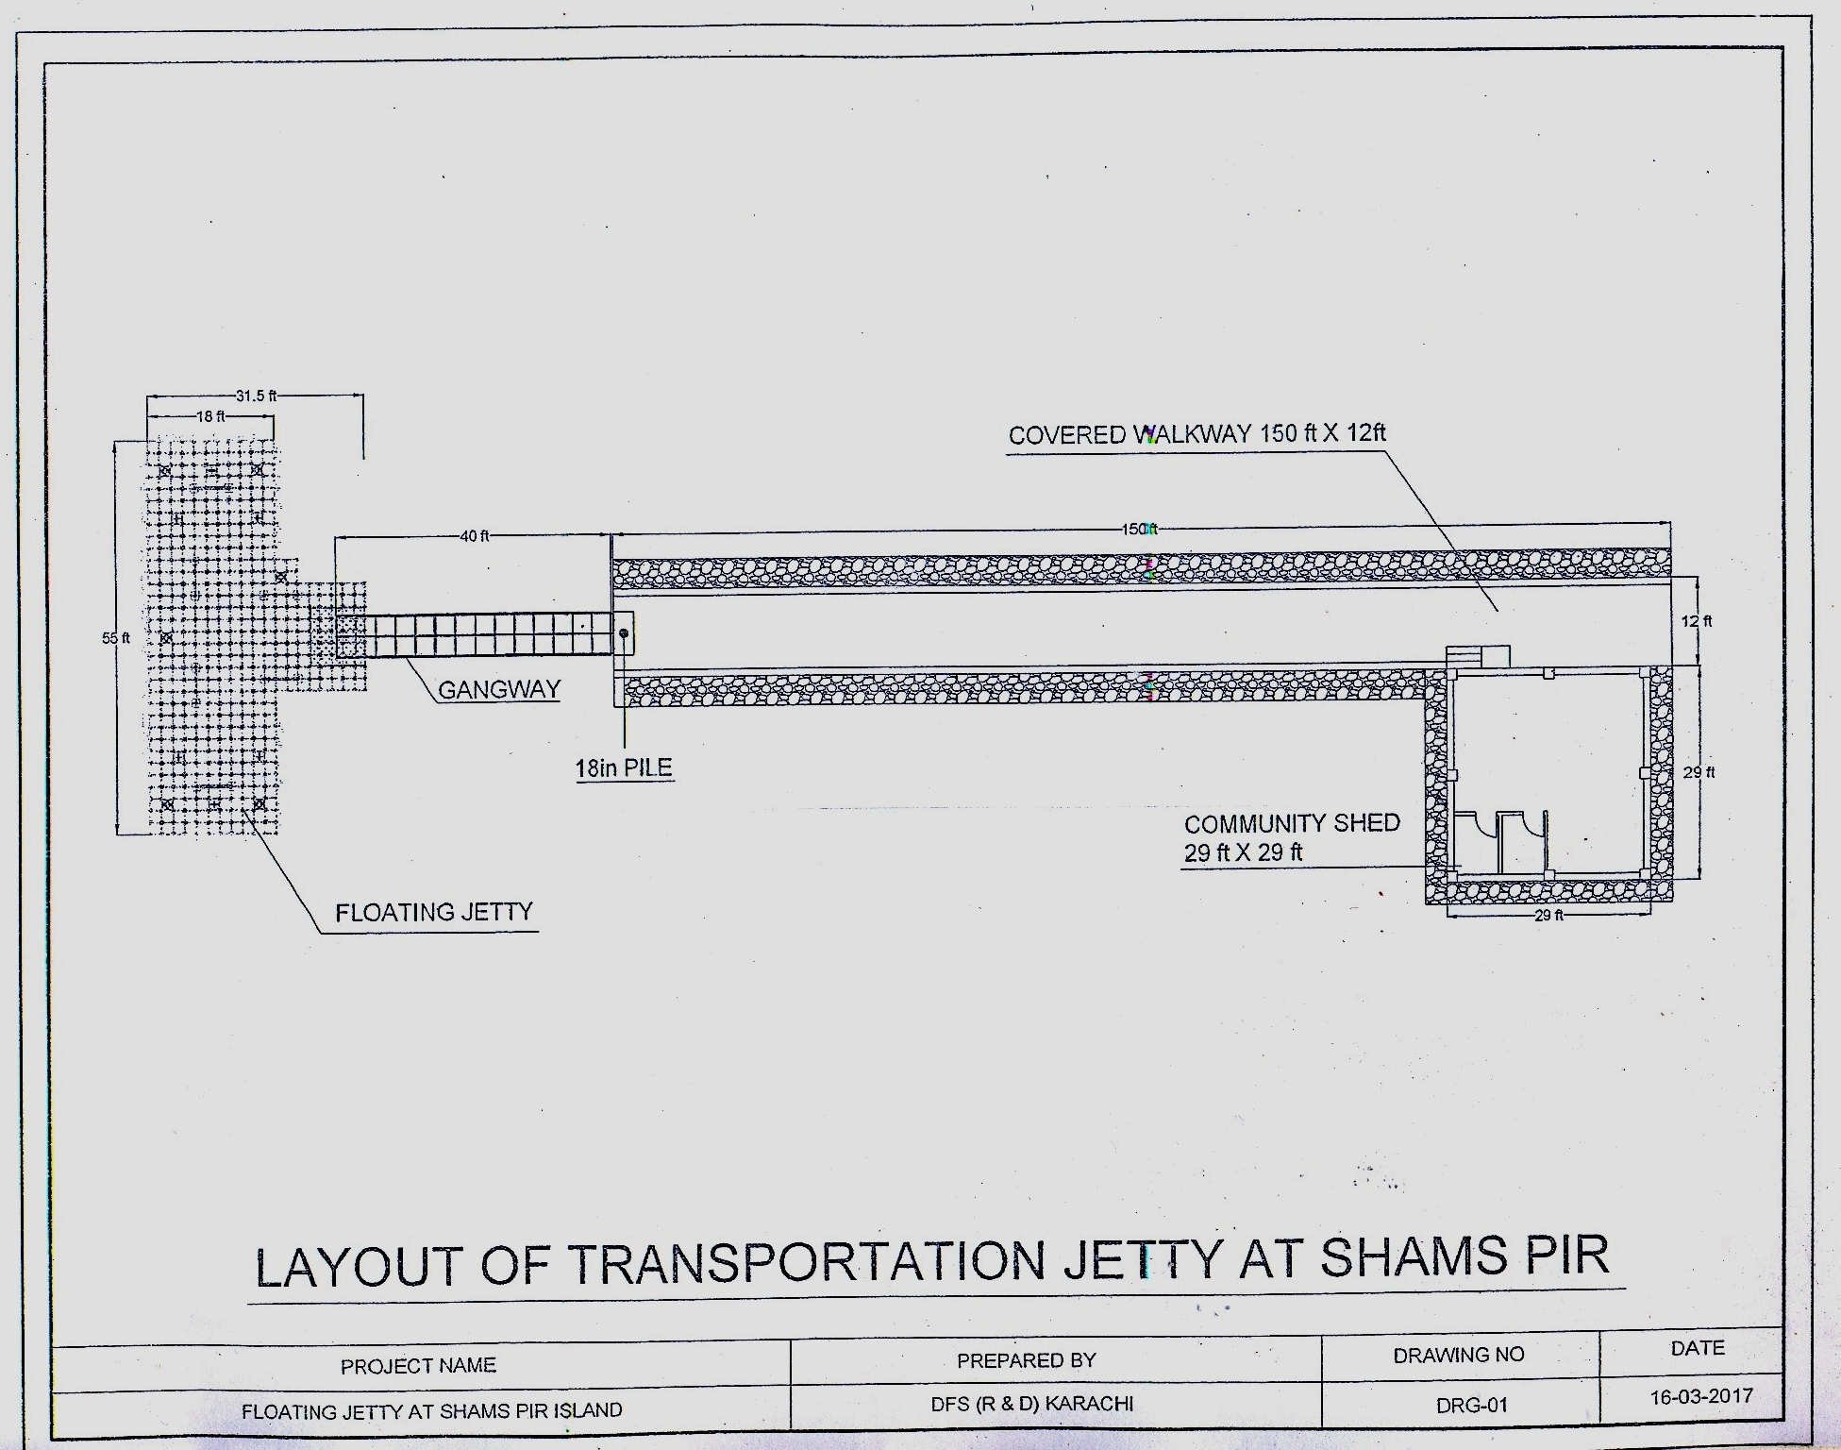

(WORKS, GOOD & SERVICES )
FINANCIAL YEAR 2017-2018

“FLOATING JETTY FOR TRANSPORTATION AT SHAMS PIR ISLAND, UC-41 BABA BHIT, KEAMARI TOWN, KARACHI WEST”

S.# | DESCRIPTION OF WORK | ESTIMATED TOTAL COST | FUNDS ALLOCATED | SOURCE OF FUNDS (ADP/NON ADP) | PROPOSED PROCUREMENT METHOD | TIMING OF PROCUREMENT |  |  |  | REMARKS
 |  |  |  |  |  | 1st Qtr. | 2nd Qtr. | 3rd Qtr. | 4th Qtr.
1 | Floating jetty for Transportation at Shams Pir Island, UC-41 Baba Bhit, Keamari Town, Karachi West | Rs. 34.72 million |  | C.M Directive | Single stage One envelope procedure | √ | √ | √ | √

DETAILS LIST OF “FLOATING JETTY FOR TRANSPORTATION AT SHAMS PIR ISLAND, UC-41 BABA BHIT, KEAMARI TOWN, KARACHI WEST”. TO BE PURCHASED OF THE YEAR 2017-18, IN RESPECT OFFICE OF THE DIRECTORATE OF FISHERIES SINDH RESEARCH & DEVELOPMENT KARACHI

S.NO | ITEMS
1 | Floating jetty for Transportation at Shams Pir Island, UC-41 Baba Bhit, Keamari Town, Karachi West

